Day 9 for github, day 11 for ChatGPT
Exercise 1
Total count of employees every department
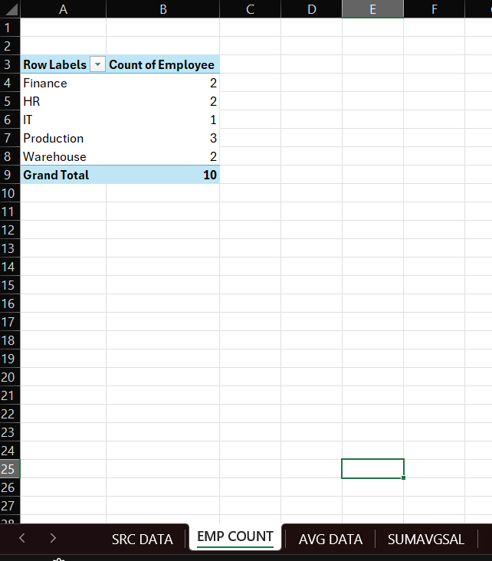
Exercise 2
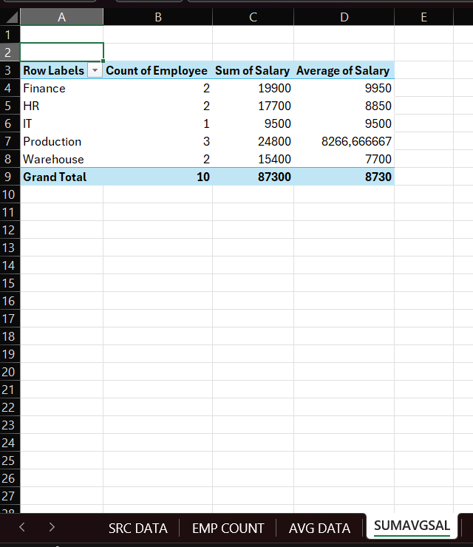
Exercise 3
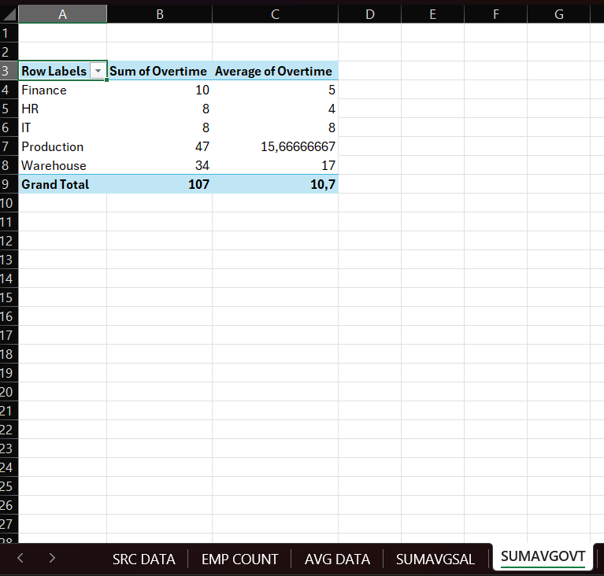

Exercise 4
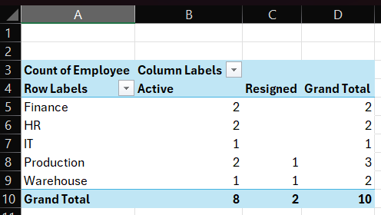

Exercise 5
(imagine this day 1 meeting, because HR do not have data from every dept)
After we saw data employees. Department that has more employee is Production and others average is 2 points. And department that has highest salary is on Finance and average for all dept is on 8730. in this meeting, I couldn't talk about them(salary every dept or total employees)

there something that I want to investigate about, it's about overtime!
Let see on data (SUMAVGOVT on the sheet), every department has overtime, and the highest is Production dept, and average overtime is around 10 point. The problem is on the average data
Warehouse has the highest point, it's 17, almost 2 point higher than production!
the production has 3 manpower and warehouse is only 2, how big different, right?
What they do?
Can I ask data to every dept, specially warehouse and production dept.
I saw the overtime number is not kidding.
I need raw material data, employee (yes I have data on HR, but I want more specific on the field) because I can't control real life condition, I just can control data on the virtual!
and for sure need some data about , PR data (finished good, reject or if there are more data that I need you can give all of them, anything about production)
I can't make decision how it will be, because I don't have real data.

